Greedy Algorithm --- Task Scheduling

Fractional Knapsack

**Task Scheduling**

# What is it?

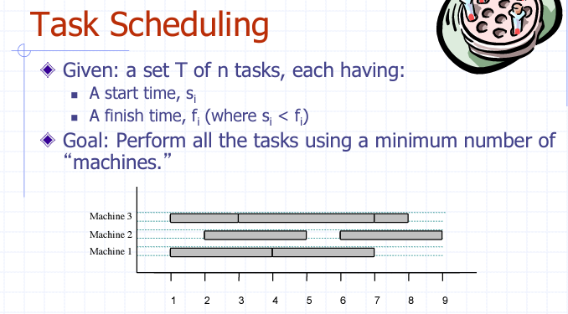

# How to solve/give algorithm, explain it, justify runtime, prove correctness by lower bound argument

## Algorithm

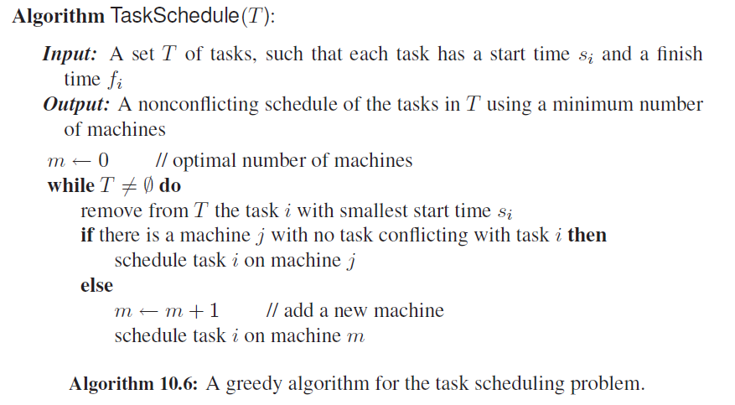

## Justify runtime

This Algo uses heap-based PQ to store task in T. Thus, remove Task i from T with smallest start time si once, will take O(log n) time.

While-loop takes O(n) in worst case.

Therefore, runtime: O(log n) * O(n) = O(n log n)

## Prove correctness by lower bound argument

Proof:

TaskSchedule Algo use k Machines to schedule k tasks.

Let i be the first task scheduled on Machine k.

Assume we can only use k – 1 Machines.

When we schedule task I on 1 ~ k-1 Machines, we find that task i conflicts with all other tasks on these Machines.

Therefore, it is impossible for use to schedule all tasks in T using only k-1 machines. K is the minimal number of machines for all tasks in T.

This proof uses lower-bound argument.

# Difference between Task Scheduling and Telescope Scheduling problems

1: Greedy Algo vs Dynamic programming

2: Greedy 算法特点 vs Simple Subproblem, Subproblem Optimality, Subproblem Overlap

3: Greedy deals with conflict. When a task conflict with other task on all machines, Task Scheduling problem is allowed to add a new machine to solve tasks.

However, for Telescope Schedule, we only have one telescope or Machine to solve items. So we must use a Algo which can solve problem on a global view.